**FUNCTIONAL AND TECHNICAL COMBINED DOCUMENTATION**

**Page (35): Company Events (Front End Url:** http://localhost:8100/page35/Page35)

**Functional Picture:**

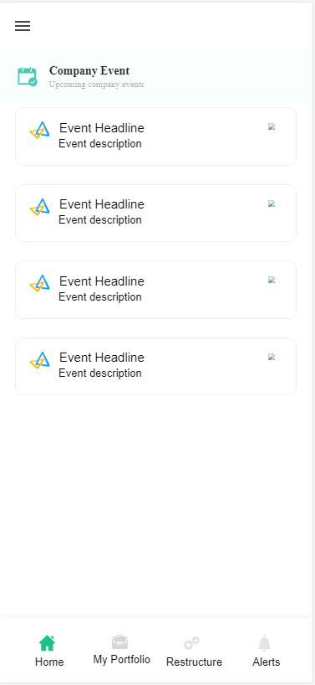

**In this Page, the user is going to see the corporate actions, online announcements, board meetings and financial results.**

**Technical Explanation (Front End and Back End):**

**In Page35.tsx, we are calling following 1 API:**

1. RSSFeedParserAPI: see backend python file. In this we are doing GET requests.

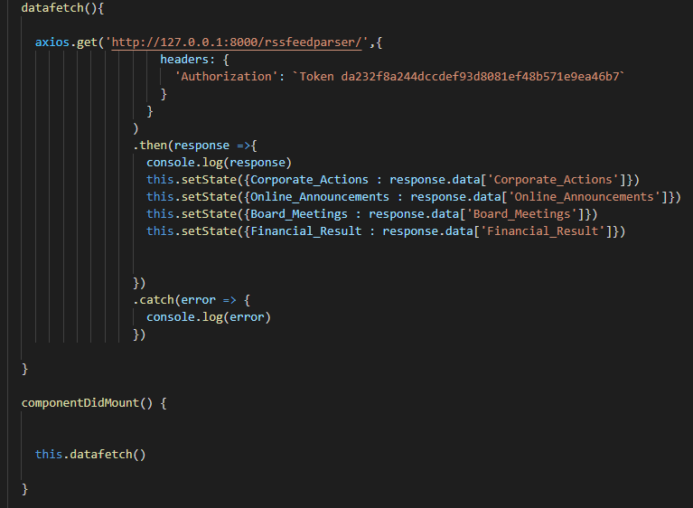

**As you can see, we are calling the** RSSFeedParserAPI

**using this url:** [**http://127.0.0.1:8000/rssfeedparser/**](http://127.0.0.1:8000/rssfeedparser/)**. In this we are taking the RSS feed of the stocks that are in the portfolio of the user.**

**Kindly see the given below backend Code for this GET request.**

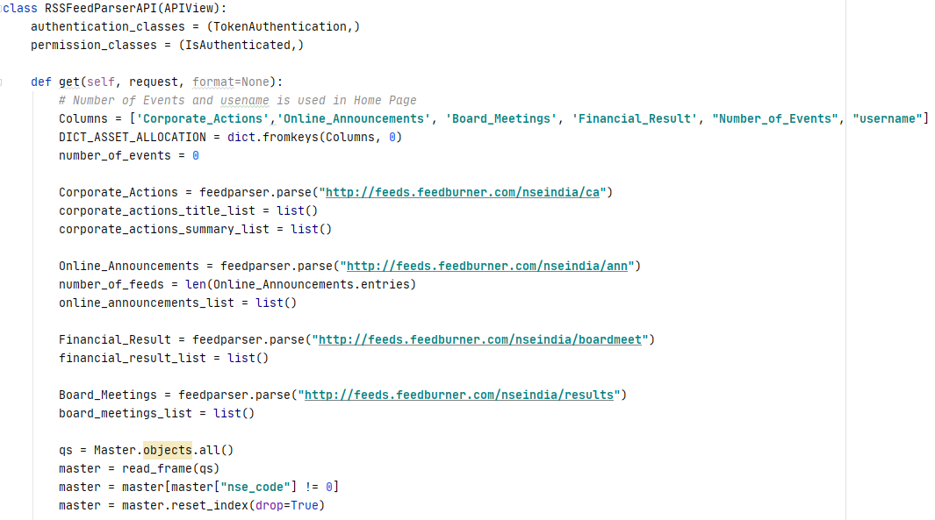

RSS (Rich Site Summary) is a format for delivering regularly changing web content. Many news-related sites, weblogs and other online publishers syndicate their content as an RSS Feed to whoever wants it. In python we take help of the below package to read and process these feeds.

Feed Title and Posts

In the above example we read the title and head of the rss feed.

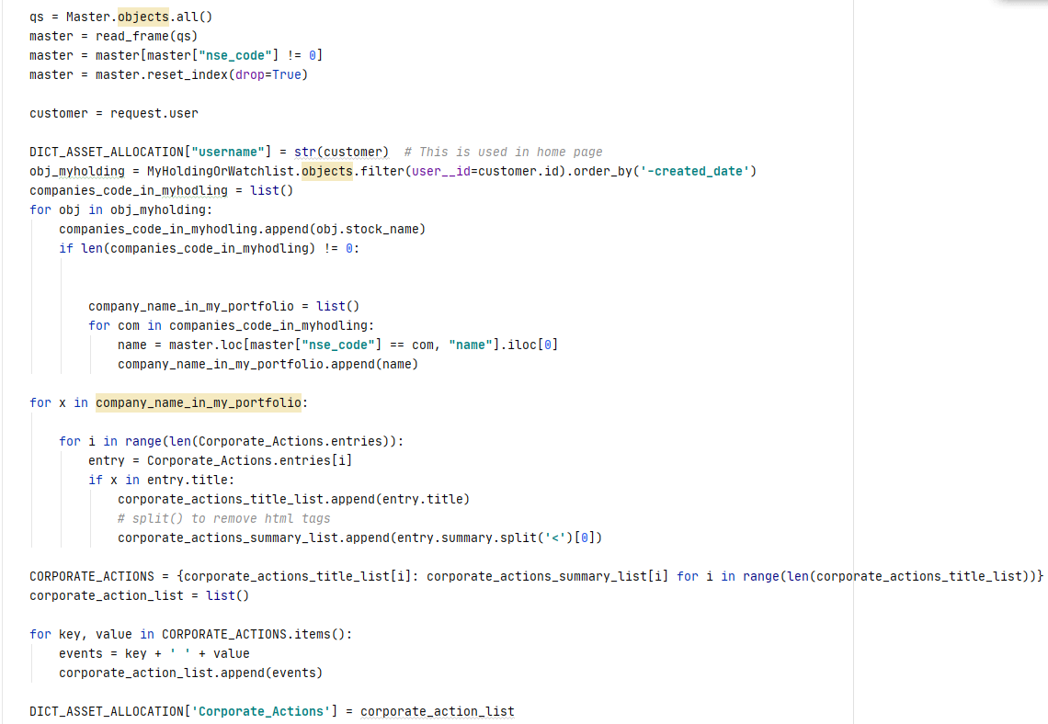

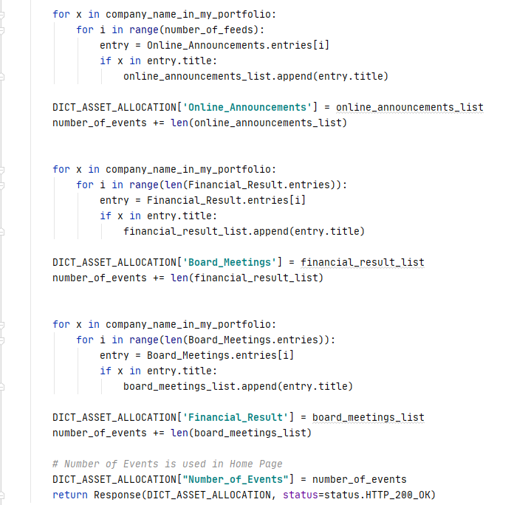

RSS (Rich Site Summary) is a format for delivering regularly changing web content. Many news-related sites, weblogs and other online publishers syndicate their content as an RSS Feed to whoever wants it. In python we take help of the below package to read and process these feeds.

**DONE!!!**